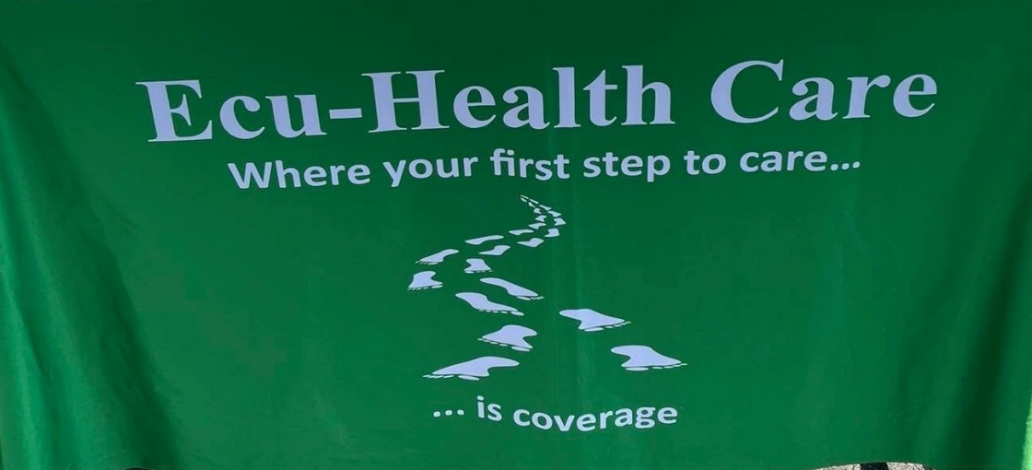

in this issue >>>
Meet our Team
Preview our accomplishments
Learn about upcoming changes
Our outreach activities
Programs available
Ecu-Health Care 2026 Annual Appeal

Our Board of Directors:
Charles Nemser– President
Anthony Smeglin – Vice President
Susan Durocher – Treasurer
Paula Consolini - Clerk
David Anderson
Suzanne Stinson
Bonnie Brown

Our Dedicated Staff:

Karen Baumbach – Executive Director
Navigator/SHINE counselor

Melissa Montoya – Outreach Specialist
Navigator/SHINE counselor

Jessica Horn – Health coverage counselor
Navigator/SHINE counselor

Rebecca Harris – Health coverage counselor
Navigator

Kimberly Miller – Receptionist
Navigator/Support Staff

In 2025, local donations made it possible for Ecu-Health Care to assist you, your family, friends and neighbors enroll in the following health coverage programs:

Key Impacts of the “One Big Beautiful Bill Act” on MassHealth Members with massive, restrictive changes to Massachusetts healthcare, resulting in billions of dollars in funding cuts beginning in 2027.
- Massive Funding Cuts: The bill significantly slashes federal Medicaid dollars, heavily restricting money that previously went to community health centers, hospitals, and nursing facilities.
- Semi-Annual Redeterminations: Members are now required to recertify their eligibility every six months instead of annually, which increases administrative hurdles and the risk of losing coverage due to paperwork.
- Work Requirements: Able-bodied adults are subject to community engagement (work, education, or volunteering) requirements to maintain coverage, which carries heavy paperwork burdens and risks coverage losses for those unable to consistently verify hours.
- Immigrant Coverage Cuts: The bill limits MassHealth eligibility for a specific group of lawfully present non-citizens, such as refugees and asylees, forcing them to transition off the program.
.
The staff at Ecu-Health Care will be available to assist these members as they navigate these policy implementations by providing one-to-one education, enrollment assistance and case-management.

Congue nihil imperdiet doming id quod mazim placerat facer minim veni am ut wisi enim ad minimeniam, quis erat nostr uexerci
Meet our team

A local non-profit whose mission is to help north Berkshire residents of all ages access needed health coverage

Providing outreach to local area residents

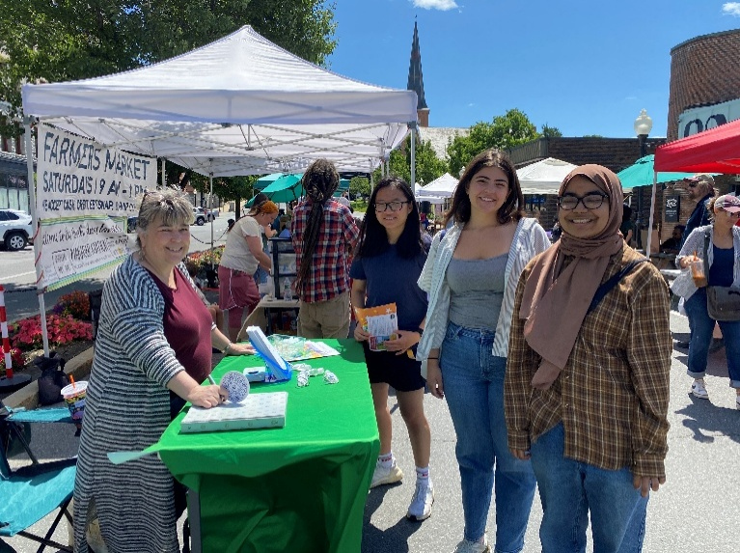
Berkshire Friendship Food Pantry
Berkshire Food Project
Mobile Food Truck – Brien Center
Have Hope Recovery
Local Farmer’s Market
First Baptist Church Community Lunch program
Berkshire Community Action – Community Partnership
Northern Berkshire Community Coalition Forum
National Night Out Celebration
City of North Adams Downtown Celebration
Backpacked for success – backpack distribution
Williamstown Holiday Walk
Children’s Fall Foliage Fair
Adams Council on Aging Wellness Fair
Berkshire County Baby Bonanza
Veteran’s Services Coffee Hour and Luncheons
Berkshire Community Stakeholders
North Adams Parklet Coffee Hour

Health Coverage Programs Available in Massachusetts

ConnectorCare
Comprehensive health insurance for individuals with income up to 400% of the federal poverty level may be eligible for subsidies from the Commonwealth in addition to the federal government.

Qualified Health Plans
Comprehensive health insurance plans offered through the Massachusetts Health Connector.

MassHealth and the Children’s Medical Security Plan
Comprehensive health coverage programs available for income-eligible individuals and families.

MassHealth Premium Assistance
Some families who have employer sponsored insurance may be able to get help with the cost of their premiums from the Commonwealth.

Health Safety Net
Income-eligible residents of Massachusetts are eligible for free care at acute hospitals and community health centers in Massachusetts.

Options for Seniors and Medicare Beneficiaries

SHINE Program
Offers free information, counseling and assistance to help Medicare beneficiaries understand benefits and all available insurance and financial assistance options.

Medicare Part D Drug Plan
Prescription drug coverage available through Medicare. Several companies to choose from with varying costs. Financial help may be available (see LIS below).

Medicare Savings Programs:

Qualified Medicare Beneficiary (QMB)
Pays for Medicare Part A and B Premiums, deductibles,
coinsurance and copays, and provides help with Part D premiums, deductibles and copays.

Specified Low-income Medicare Beneficiary (SLMB)
Qualifying Individual (QI-1)
Pays for Medicare Part B Premiums, and provides help with
Part D premiums, deductibles and copays.

Our staff are both Certified Health Connector Navigators and SHINE counselors.
We can assist with all your public health insurance needs

