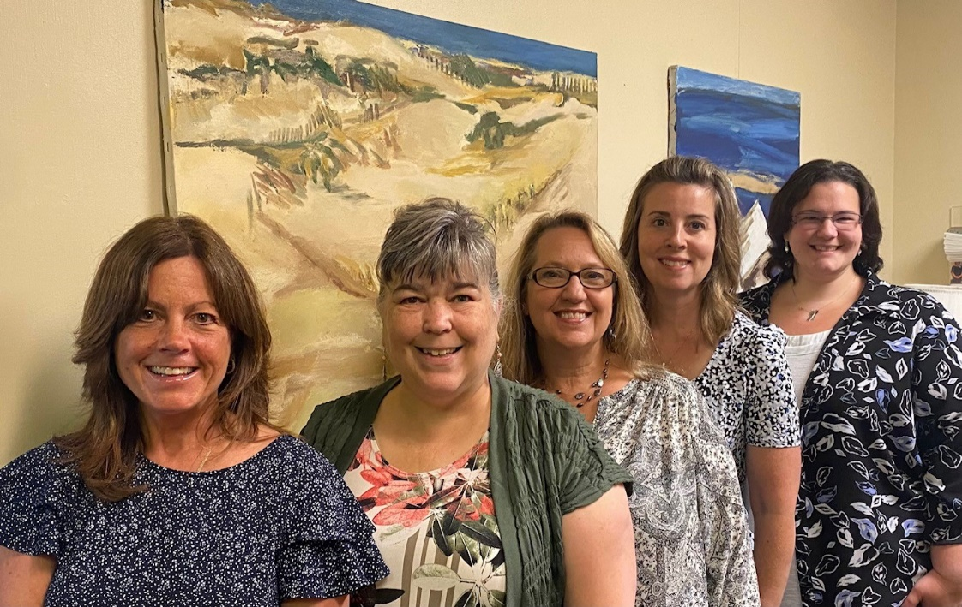

***in this issue >>>***

*Meet our Team*

*Preview our accomplishments*

*Our outreach activities*

*MA Health Insurance Programs*

*Options for Seniors*

***Ecu-Health Care – Annual Newsletter 2024***

**A local non-profit whose mission is to help north Berkshire residents of all ages access needed health coverage**

***Meet our Team:***

**Our Dedicated Staff:**

Karen Baumbach –Executive Director

Navigator/SHINE counselor

Melissa Montoya – Outreach Specialist

Navigator/SHINE counselor

Jessica Horn – Navigator

Rebecca Harris – Navigator

Kimberly Miller –Receptionist

Navigator/Support Staff

**Our Board of Directors:**

Don LeBreux– President

Charles Nemser – Vice President

Anthony Smeglin, MD – Treasurer

Nancy Apkin - Clerk

Lawrence Taft

Susan Durocher

Paula Consolini, Ph. D

Stephanie Bosley, MPA

*In 2023, local donations made it possible for Ecu-Health Care to assist you, your family, friends and neighbors enroll in the following health coverage programs:*

*Ecu-Health Care provides one-to-one education, enrollment assistance and case-management for all public health programs including MassHealth and Qualified Health Plans that have been implemented under the Affordable Care Act.*

*Throughout 2023, our staff assisted numerous MassHealth members with their eligibililty renewal applications as a requirement of the Medicaid unwinding of the Families First Coronavirus Response Act. This protection which allowed MassHealth members to keep their coverage throughout the Public Health Emergency came to an end on April 1, 2023.*

*As many individuals no longer qualilfied for MassHealth coverage, we provided education and enrollment assistance into plans available through the Massachusetts Health Connector. A 2-year pilot program expanding access to ConnectorCare coverage made it possible for more people to qualify for both affordable coverage and care.*

Congue nihil imperdiet doming id quod mazim placerat facer minim veni am ut wisi enim ad minimeniam, quis erat nostr uexerci

***Providing outreach and education at local area events and to other community organizations***

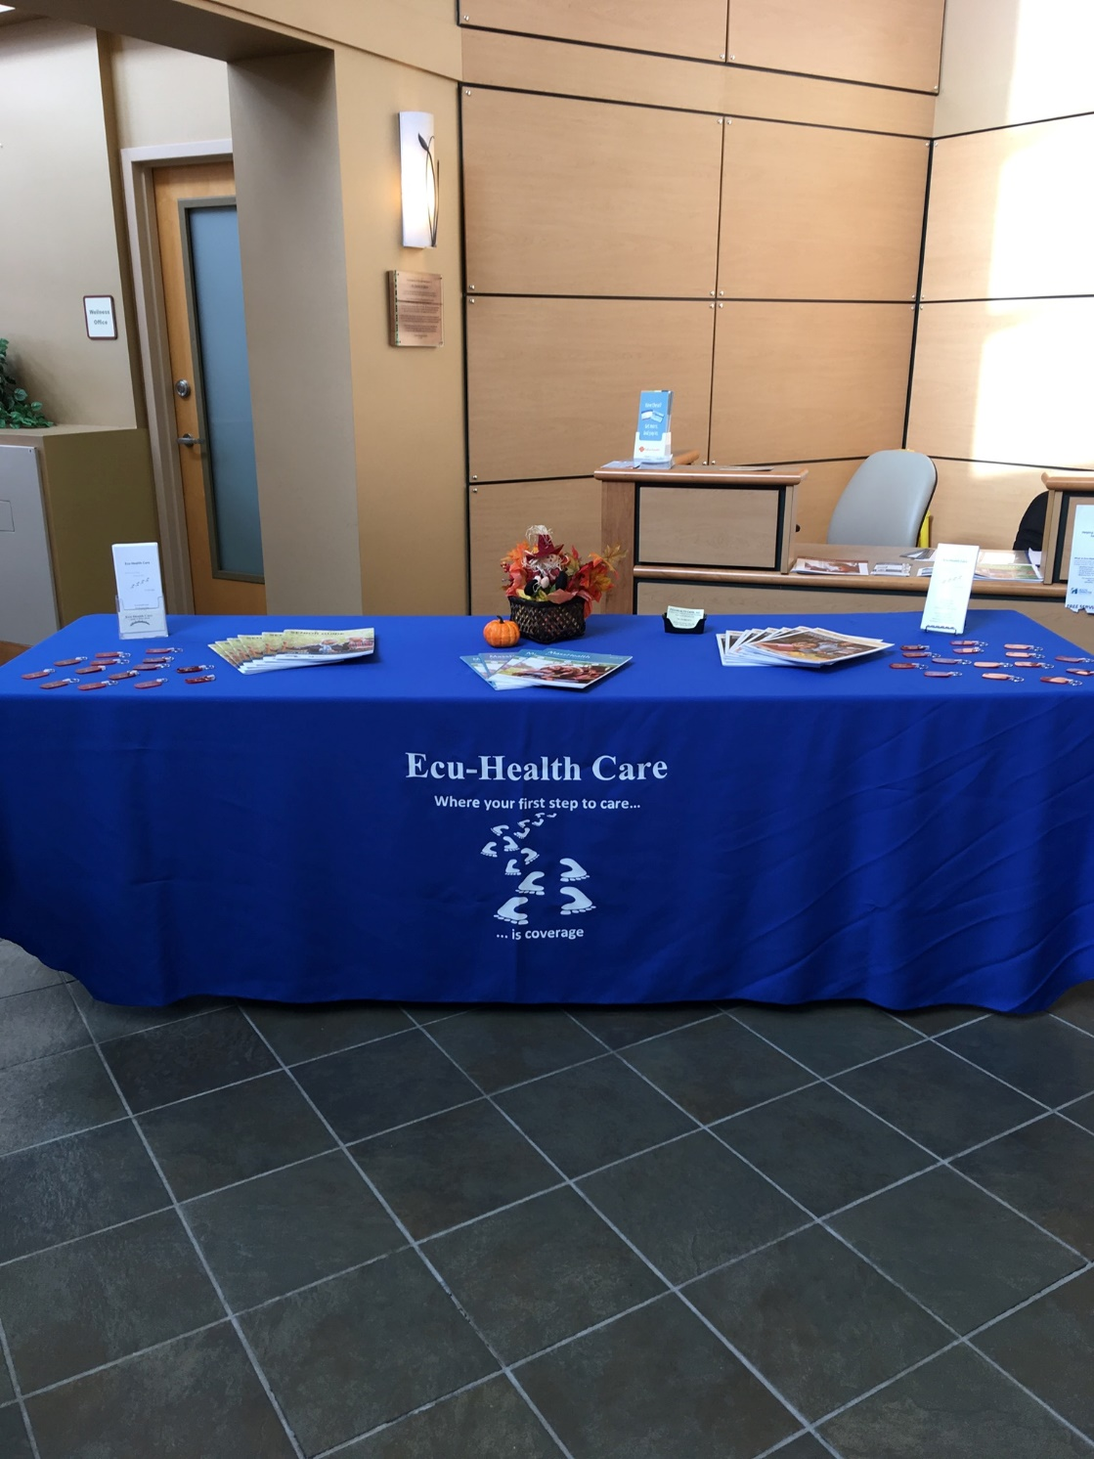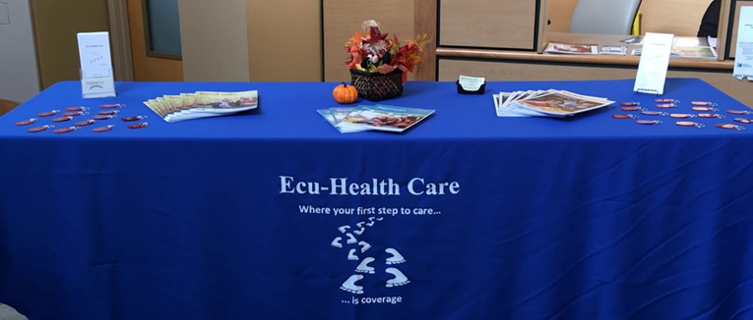

Adams COA Wellness Fair Backpack for Success Mayor's Kick off

BCAC Community Coffee hour Al Nelson Berkhire Friendship Ctr MCLA Resource Fair

Berkshire Food Project Childrens Fall Foliage Fair Mobile Food Truck

Community Baby Shower Community Partnership National Night Out

Downtown Celebration NBCC - monthly forum Rally for Recovery

First Baptist Church NA Community Lunch Mary Spitzer Center Farmers Market

Health Connector Springfield Hall of Fame Mass Moca Partnership Uno Center

Mohawk Forrest Housing complex NBCC Health & Wellness Fair Parklet Coffee Hour

North Adams Public Library Wellness Fair Williamstown Resource Fair Stakeholder meeting

Williamstown Community Chest Fundraiser YMCA Wellness Wednesday

Williamstown Community Chest Holiday Walk Williamstown Council On Aging Wellness Fair

***Health Coverage Programs Available in Massachusetts***

***Qualified Health Plans***

*Comprehensive health insurance plans offered through the Massachusetts Health Connector. Individuals and families with income up to 400% of the federal poverty level may be eligible for financial subsidies from the federal government. (note: the 400% cap has been temporarily lifted under the American Rescue Plan)*

***ConnectorCare***

*Comprehensive health insurance for individuals with income up to 500% of the federal poverty level (fpl) may be eligible for subsidies from the Commonwealth in addition to the federal government.*

*(A new 2-year pilot program was established increasing the eligibility guidelines for this program from 300% to 500% of the fpl for 2024 and 2025)*

***MassHealth and the Children’s Medical Security Plan***

*Comprehensive health coverage programs available for income-eligible individuals and families.*

***MassHealth Premium Assistance***

*Some families who have employer sponsored insurance may be able to get help with the cost of their premiums from the Commonwealth.*

***Health Safety Net***

*Income-eligible residents of Massachusetts are eligible for free care at acute hospitals and community health centers in Massachusetts.*

***Options for Seniors and Medicare Beneficiaries***

***SHINE Program***

*Offers free information, counseling and assistance to help Medicare beneficiaries understand benefits and all available insurance and financial assistance options.*

***Medicare Savings Program***

*Provides eligible Medicare members with financial assistance with their Medicare Part B premium, automatic eligibility for “extra help” with the Part D prescription costs and for some individuals, will also cover the cost of Medicare deductibles and copayments.*

***Medicare Part D Drug Plan***

*Prescription drug coverage available through Medicare. Several companies to choose from with varying costs. Financial help may be available (see LIS below).*

***LIS (Low Income Subsidy)***

*Individuals with limited income and assets may get help paying their monthly Part-D premium, deductible and co-payments.*

***Prescription Advantage***

*Provides prescription drug coverage to Massachusetts residents who fall into the Medicare Part-D coverage gap*

*OUR STAFF ARE BOTH CERTIFIED MASSACHUSETTS NAVIGATORS AND SHINE COUNSELORS AND CAN ASSIST WITH ALL YOUR HEALTH INSURANCE QUESTIONS RELATED TO RETIRMENT*